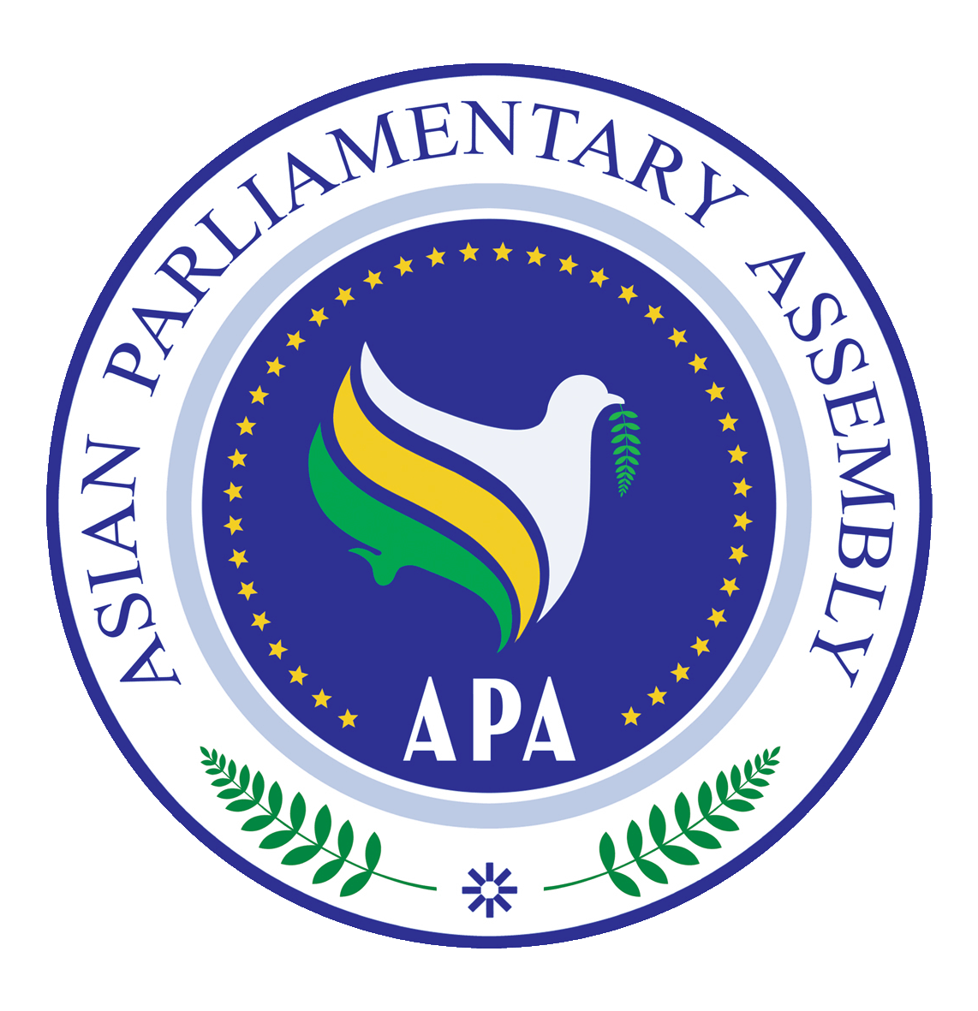
Asian Parliamentary Assembly
Parliamentary Forum on Research and Library Cooperation
In commemoration of 15 years of Parliamentary Achievements in Asia
(VIRTUAL EVENT)
Tehran- Islamic Republic of Iran
Tuesday, 17 May 2022

Registration Form
(4/11/2022 by APA Secretariat)
Delegation of: …………………………………………..
Tel. No: …………………………….. | Fax No: ……………………………..
Mobile No: …………………………….. | Email Address: …………………….………..

Please specify the topic and the Session in which you are interested to speak:
……………………………………………………………………………………………………………………………………………………………………………………………………………………

Kindly complete this form and send it no later than May 13, 2022 to the APA Secretariat:
Email: secretariat@asianparliament.org Fax: (+98-21) 33517408 Phone: (+98-21) 33517406-7

No. | First Name | Last Name | Position | Photo
1
2
3
4

